ASSIGNMENT-14
TASK-1:
: Create a Responsive Web Page Layout
Instructions:
- Design a basic web page layout with a header, main content area, and footer using HTML and CSS.
- Use AI to assist in generating responsive CSS for different screen sizes.
- Ensure the layout is clean and visually organized.
CODE:
HTML CODE:
<!DOCTYPE html>
<html lang="en">
<head>
<meta charset="UTF-8" />
<meta name="viewport" content="width=device-width, initial-scale=1.0" />
<title>Savika's Portfolio</title>
<link rel="stylesheet" href="styles.css" />
</head>

<body>
<header>
<img src="savika.jpg" alt="Savika's Profile Photo" />
<h1>Savika Chidara</h1>
<nav>
<ul>
<li><a href="#about">About Me</a></li>
<li><a href="#skills">Skills</a></li>
<li><a href="#projects">Projects</a></li>
<li><a href="#contact">Contact</a></li>
</ul>
</nav>
</header>

<main>
<section id="about">
<h2>About Me</h2>
<p>Hello! I am Savika, a passionate web developer.<br>
I specialize in creating websites with a background in computer science.<br>
I bring aesthetic appeal to my work and enjoy learning new technologies in web development.<br>
I am always exploring new ways to improve my work.</p>
</section>

<section id="skills">
<h2>Technical Skills</h2>
<ol>
<li>HTML</li>
<li>C Language</li>
<li>Python</li>
<li>JavaScript</li>
<li>SQL</li>
</ol>
</section>

<section id="projects">
<h2>Projects</h2>
<ol>
<li>
<h3>Portfolio</h3>
<p>A personal portfolio built with HTML5 to showcase my skills, projects, and contact information.</p>
</li>
<li>
<h3>Task Manager App</h3>
<p>A full-stack task management application using React and Node.js.</p>
</li>
</ol>
</section>

<section id="contact">
<h2>Contact</h2>
<address>
<p>Email: <a href="mailto:xyz@gmail.com">xyz@gmail.com</a></p>
<p>Phone: 87121xxxxx</p>
<p>LinkedIn: <a href="https://www.linkedin.com/in/savika-chidara">savika-chidara</a></p>
<p>GitHub: <a href="https://github.com/savika-chidara">savika-chidara</a></p>
</address>
</section>
</main>

<footer>
<p>&copy; 2025 Savika Chidara. All rights reserved.</p>
</footer>

<script src="script.js"></script>
</body>
</html>
CSS CODE:
/* Basic Reset */
* {
margin: 0;
padding: 0;
box-sizing: border-box;
}

body {
font-family: Arial, sans-serif;
line-height: 1.6;
background-color: #f4f4f4;
color: #333;
padding: 20px;
max-width: 900px;
margin: auto;
}

/* Image styling */
img {
max-width: 150px;
border-radius: 50%;
display: block;
margin: 20px auto;
}

/* Header */
header {
text-align: center;
margin-bottom: 30px;
}

header h1 {
font-size: 2.8rem;
margin-bottom: 10px;
color: #222;
}

/* Navigation */
nav ul {
list-style: none;
display: flex;
justify-content: center;
gap: 30px;
}

nav ul li a {
text-decoration: none;
color: #333;
font-weight: 600;
font-size: 1.1rem;
transition: color 0.3s ease;
}

nav ul li a:hover {
color: #007BFF;
}

/* Sections */
section {
background: white;
padding: 20px 25px;
margin-bottom: 25px;
border-radius: 8px;
box-shadow: 0 0 8px rgba(0,0,0,0.1); }

section h2 {
margin-bottom: 15px;
border-bottom: 2px solid #007BFF;
padding-bottom: 8px;
color: #007BFF;
}

section p, section ol {
font-size: 1rem;
margin-top: 10px;
}

section ol {
padding-left: 20px;
}

section ol li {
margin-bottom: 8px;
}

/* Project titles */
section ol li h3 {
margin-bottom: 5px;
color: #444;
}

/* Contact links */
address p {
margin-bottom: 8px;
font-style: normal;
}

address a {
color: #007BFF;
text-decoration: none;
}

address a:hover {
text-decoration: underline;
}

/* Footer */
footer {
text-align: center;
padding: 15px 0;
font-size: 0.9rem;
color: #777;
border-top: 1px solid #ddd;
margin-top: 40px;
}

/* Responsive Design */
@media (max-width: 600px) {
nav ul {
flex-direction: column;
gap: 15px;
}
img {
max-width: 120px;
}
}
JS CODE:
// Select all nav links
const navLinks = document.querySelectorAll('nav ul li a');

navLinks.forEach(link => {
link.addEventListener('click', (e) => {
e.preventDefault();
const targetID = link.getAttribute('href').slice(1);
const targetSection = document.getElementById(targetID);
if (targetSection) {
targetSection.scrollIntoView({ behavior: 'smooth' });
}
});
});

OUTPUT:
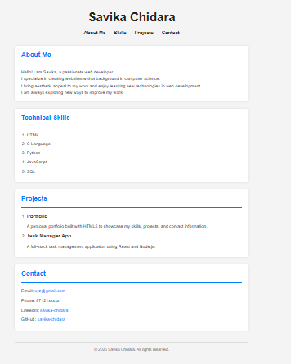

TASK-2: Interactive Button with JavaScript
Instructions:
- Create a button on a web page.
- Use AI to generate JavaScript code that displays an alert message when the button is clicked.
- Ensure the code is clean and well-commented.
Code:
HTML CODE:
<!DOCTYPE html>
<html lang="en">
<head>
<meta charset="UTF-8">
<title>Interactive Button</title>
<!-- Link to external CSS file -->
<link rel="stylesheet" href="style.css">
</head>
<body>

<!-- Button Element -->
<button id="myButton">Click Me!</button>

<!-- Link to external JavaScript file -->
<script src="script.js"></script>
</body>
</html>

CSS CODE:
/* Styling for the button */
button {
padding: 10px 20px;
font-size: 16px;
background-color: #3498db;
color: white;
border: none;
border-radius: 4px;
cursor: pointer;
}

/* Add hover effect */
button:hover {
background-color: #2980b9;
}

JS CODE:
// Select the button by its ID
const button = document.getElementById('myButton');

// Add a click event listener
button.addEventListener('click', function() {
// Show an alert when the button is clicked
alert('Button clicked!');
});

OUTPUT:
When the button was clicked it shows like an alert box.
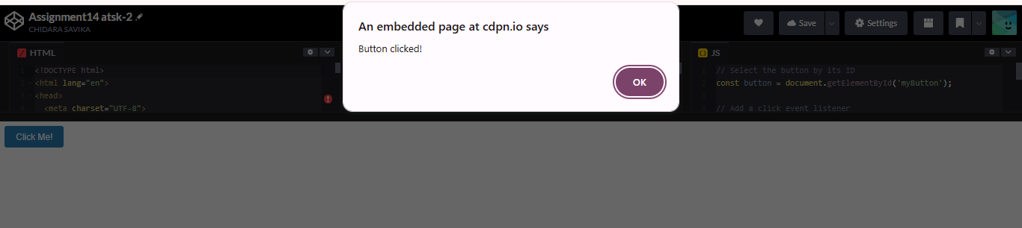

TASK-3: Form with Validation
Instructions:
- Design a contact form with fields: Name, Email, Message.
- Use AI to generate JavaScript code for form validation (e.g., non-empty fields, valid email format).
Add inline error messages if input is invalid

CODE:
HTML CODE:
<!DOCTYPE html>
<html lang="en">
<head>
<meta charset="UTF-8">
<title>Contact Form with Validation</title>
<link rel="stylesheet" href="style.css">
</head>
<body>

<div class="container">
<h2>Contact Us</h2>

<!-- Success Message -->
<div id="successMessage" class="success-message"></div>

<!-- Contact Form -->
<form id="contactForm" novalidate>
<div class="form-group">
<label for="name">Name:</label>
<input type="text" id="name" />
<span class="error-message" id="nameError"></span>
</div>

<div class="form-group">
<label for="email">Email:</label>
<input type="text" id="email" />
<span class="error-message" id="emailError"></span>
</div>

<div class="form-group">
<label for="message">Message:</label>
<textarea id="message"></textarea>
<span class="error-message" id="messageError"></span>
</div>

<button type="submit">Submit</button>
</form>
</div>

<script src="script.js"></script>
</body>
</html>

CSS CODE:
body {
font-family: Arial, sans-serif;
background-color: #f4f4f4;
padding: 20px;
}

.container {
max-width: 500px;
margin: auto;
background: white;
padding: 30px;
border-radius: 8px;
box-shadow: 0 0 10px rgba(0,0,0,0.1);
}

h2 {
text-align: center;
}

.form-group {
margin-bottom: 15px;
}

label {
display: block;
font-weight: bold;
}

input, textarea {
width: 100%;
padding: 10px;
margin-top: 5px;
box-sizing: border-box;
}

textarea {
resize: vertical;
height: 100px;
}

button {
padding: 10px 20px;
background-color: #3498db;
color: white;
border: none;
cursor: pointer;
width: 100%;
font-size: 16px;
}

button:hover {
background-color: #2980b9;
}

.error-message {
color: red;
font-size: 14px;
}

.success-message {
color: green;
font-weight: bold;
text-align: center;
margin-bottom: 15px;
}

JS CODE:
// Wait until the DOM is fully loaded
document.addEventListener('DOMContentLoaded', function () {
const form = document.getElementById('contactForm');

form.addEventListener('submit', function (event) {
event.preventDefault(); // Prevent actual form submission

// Clear previous messages
document.getElementById('successMessage').textContent = '';
document.getElementById('nameError').textContent = '';
document.getElementById('emailError').textContent = '';
document.getElementById('messageError').textContent = '';

// Get input values
const name = document.getElementById('name').value.trim();
const email = document.getElementById('email').value.trim();
const message = document.getElementById('message').value.trim();

let isValid = true;

// Validate name
if (name === '') {
document.getElementById('nameError').textContent = 'Name is required.';
isValid = false;
}

// Validate email
if (email === '') {
document.getElementById('emailError').textContent = 'Email is required.';
isValid = false;
} else if (!isValidEmail(email)) {
document.getElementById('emailError').textContent = 'Please enter a valid email.';
isValid = false;
}

// Validate message
if (message === '') {
document.getElementById('messageError').textContent = 'Message is required.';
isValid = false;
}

// If all fields are valid
if (isValid) {
document.getElementById('successMessage').textContent = 'Form submitted successfully!';
form.reset(); // Clear form fields
}
});

// Email format validation using regex
function isValidEmail(email) {
const emailPattern = /^[^\s@]+@[^\s@]+\.[^\s@]+$/;
return emailPattern.test(email);
}
});

OUTPUT:
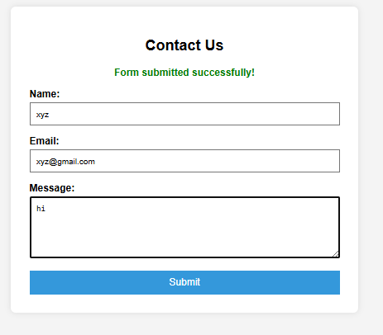

TASK-4: Dynamic Content Generation
Instructions:
- Create a list of items (e.g., product names) using HTML.
- Use AI-generated JavaScript to dynamically add or remove items from the list when a button is clicked.
CODE:
HTML CODE:
<!DOCTYPE html>
<html lang="en">
<head>
<meta charset="UTF-8">
<title>Dynamic List</title>
<link rel="stylesheet" href="style.css">
</head>
<body>

<div class="container">
<h2>Product List</h2>

<!-- Buttons -->
<div class="buttons">
<button id="addItemBtn">Add Item</button>
<button id="removeItemBtn">Remove Item</button>
</div>

<!-- Item List -->
<ul id="itemList">
<li>Product 1</li>
<li>Product 2</li>
<li>Product 3</li>
</ul>
</div>

<script src="script.js"></script>
</body>
</html>

CSS CODE:
body {
font-family: Arial, sans-serif;
background: #f5f5f5;
padding: 40px;
}

.container {
max-width: 400px;
margin: auto;
background: white;
padding: 30px;
border-radius: 8px;
box-shadow: 0 2px 8px rgba(0, 0, 0, 0.1);
}

h2 {
text-align: center;
}

ul {
list-style-type: disc;
padding-left: 20px;
}

li {
margin: 8px 0;
font-size: 16px;
}

.buttons {
display: flex;
justify-content: space-between;
margin-bottom: 20px;
}

button {
padding: 10px 15px;
font-size: 14px;
background-color: #3498db;
color: white;
border: none;
border-radius: 4px;
cursor: pointer;
}

button:hover {
background-color: #2980b9;
}

JS CODE:
// Wait until the DOM is fully loaded
document.addEventListener('DOMContentLoaded', function () {
const itemList = document.getElementById('itemList');
const addItemBtn = document.getElementById('addItemBtn');
const removeItemBtn = document.getElementById('removeItemBtn');

let itemCount = itemList.children.length; // Start with existing items

// Add item when button is clicked
addItemBtn.addEventListener('click', function () {
itemCount++;
const newItem = document.createElement('li');
newItem.textContent = `Product ${itemCount}`;
itemList.appendChild(newItem);
});

// Remove last item when button is clicked
removeItemBtn.addEventListener('click', function () {
if (itemList.children.length > 0) {
itemList.removeChild(itemList.lastElementChild);
itemCount--;
}
});
});

OUTPUT:
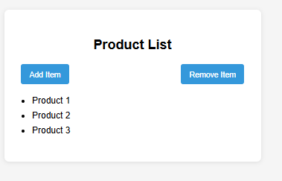
When you click on add item it will added to list.
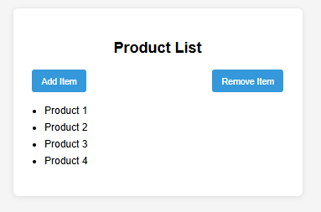
When you click on remove item it will remove from list.
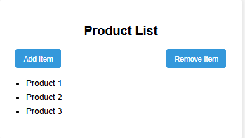

Task 5: Styled Modal Popup
Instructions:
- Use AI to generate a modal popup that opens when a button is clicked.
- Style the modal using CSS with a semi-transparent overlay.
- Include a close button that hides the modal.
CODE:
HTML CODE:
<!DOCTYPE html>
<html lang="en">
<head>
<meta charset="UTF-8">
<title>Styled Modal Popup</title>
<link rel="stylesheet" href="style.css">
</head>
<body>

<!-- Button to open the modal -->
<button id="openModalBtn">Open Modal</button>

<!-- Modal overlay and content -->
<div id="modalOverlay" class="modal-overlay">
<div class="modal-box">
<span id="closeModalBtn" class="close-button">&times;</span>
<h2>Modal Title</h2>
<p>This is some content inside the modal popup.</p>
</div>
</div>

<script src="script.js"></script>
</body>
</html>

CSS CODE:
/* General page styles */
body {
font-family: Arial, sans-serif;
background: #f0f0f0;
padding: 50px;
text-align: center;
}

/* Button styles */
button {
padding: 12px 20px;
font-size: 16px;
background-color: #3498db;
color: white;
border: none;
border-radius: 5px;
cursor: pointer;
}

button:hover {
background-color: #2980b9;
}
/* Modal overlay */
.modal-overlay {
display: none; /* Hidden by default */
position: fixed;
top: 0;
left: 0;
width: 100%;
height: 100%;
background-color: rgba(0, 0, 0, 0.5); /* Semi-transparent overlay */
justify-content: center;
align-items: center;
z-index: 1000;
}
/* Modal box */
.modal-box {
background: white;
padding: 30px;
border-radius: 8px;
width: 400px;
max-width: 90%;
position: relative;
box-shadow: 0 4px 12px rgba(0,0,0,0.3);
}
/* Close button (X) */
.close-button {
position: absolute;
top: 10px;
right: 15px;
font-size: 24px;
color: #888;
cursor: pointer;
}
.close-button:hover {
color: #333;
}
JS CODE:
document.addEventListener('DOMContentLoaded', function () {
const openModalBtn = document.getElementById('openModalBtn');
const modalOverlay = document.getElementById('modalOverlay');
const closeModalBtn = document.getElementById('closeModalBtn');

// Show the modal
openModalBtn.addEventListener('click', function () {
modalOverlay.style.display = 'flex';
});
// Close the modal when "X" is clicked
closeModalBtn.addEventListener('click', function () {
modalOverlay.style.display = 'none';
});
// Close the modal if clicking outside the modal box
modalOverlay.addEventListener('click', function (e) {
if (e.target === modalOverlay) {
modalOverlay.style.display = 'none';
}
});
});
OUTPUT:
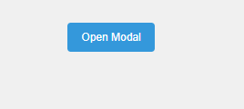
When you click on “open modal” it will show output like this.
